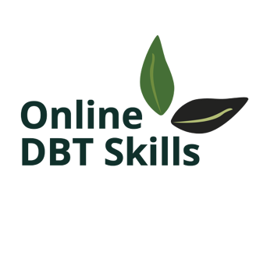
Alicia Paz
Counselor Registered Associate
alicia@onlinecopingskills.com
Professional Disclosure Statement

Philosophy and Approach: I believe that everyone benefits from mental health therapy, including learning coping skills. I employ an eclectic approach with a strong reliance on Dialectical Behavioral Therapy (DBT) and focus on short-term solution-focused therapy with collaborative goal setting.
Formal Education and Training: I hold a master’s degree in counseling psychology from the Lewis & Clark College Graduate School. Major coursework included Dialectical Behavioral Therapy (DBT) with an emphasis on Addiction Studies.
As a Counselor Registered Associate of the Oregon Board of Licensed Professional Counselors and Therapists, I abide by its Code of Ethics. To maintain my license, I am required to participate in continuing education, taking classes dealing with subjects relevant to this profession.
As a Counselor Registered Associate, I am working under the direct supervision of Nora Olsgaard, LCSW License #L6068.
Fees: My fee is $70 per hour

Your Rights:
As a client of an Oregon licensee, you have the following rights:
∗ To expect that a licensee has met the qualifications of training and experience required
by state law.
∗ To examine public records maintained by the Board and to have the Board confirm
credentials of a licensee.
∗ To obtain a copy of the Code of Ethics (Oregon Administrative Rules 833-100);
∗ To report complaints to the Board.
∗ To be informed of the cost of professional services before receiving the services.
∗ To be assured of privacy and confidentiality while receiving services as defined by the rule
or law, with the following exceptions: 1) Reporting suspected child abuse; 2) Reporting
imminent danger to you or others; 3) Reporting information required in court proceedings
or by your insurance company, or other relevant agencies; 4) Providing information
concerning licensee case consultation or supervision; and 5) Defending claims brought by
you against me.
∗ To be free from discrimination because of age, color, culture, disability, ethnicity,
national origin, gender, race, religion, sexual orientation, marital status, or socioeconomic status
status.

You may contact the Board of Licensed Professional Counselors and Therapists at
3218 Pringle Rd SE, #120, Salem, OR 97302-6312 Telephone: (503) 378-5499
Email: lpct.board@mhra.oregon.gov Website: www.oregon.gov/OBLPCT
For additional information about this counselor or therapist, consult the Board’s
website.

